# APPENDIX 2 - Studying at Queen’s: Information for the Assessment Centre

### General background

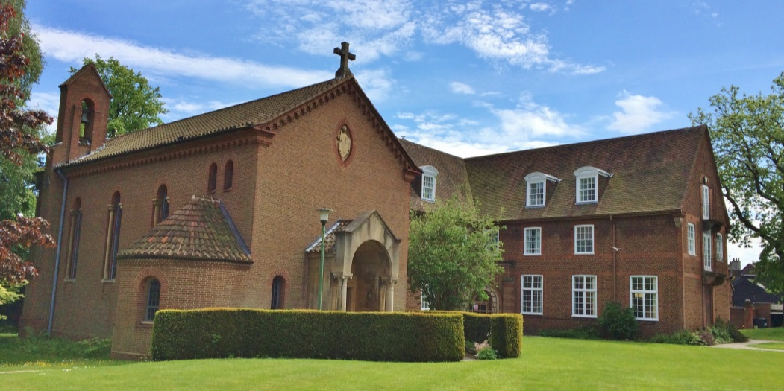

*Part of the Queen’s campus*

The Queen’s Foundation for Ecumenical Theological Education provides vocational training for students preparing to become clergy or lay ministers (and a variety of other voluntary roles) in the Methodist Church, the Church of England, and other Christian Churches.

### Validation

Programmes of study are validated by one of our partner universities. For any new student this would either be **Durham University** or **Newman University**. This is NOT a franchise arrangement. We do not receive HEFCE funding, but our programmes are designated by DfE in order to allow student to have access to any student finance that they may be entitled to. We do *not* have access therefore to ‘Access to Learning’ funds. We can assist students, however, in applying for external bursaries for part of the cost of diagnosis.

### Students, staff and facilities

The college has around 350 students, many of whom are part-time and all of whom are aged over 21. There are approximately 19 members of faculty plus a variety of associate tutors. Accommodation, lecture rooms, study space and a library are available on campus.

Many students follow pathways which involve evening classes and residential weekends and there is full tutor support during those periods.

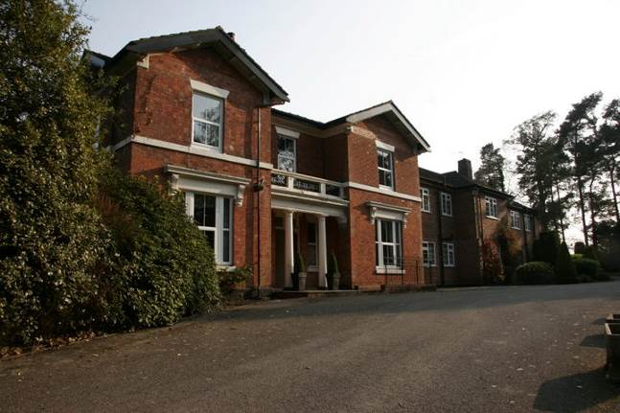

*Shallowford House*

There is a second teaching centre near Stafford (Shallowford House), which has access to Moodle, several fully equipped teaching rooms, and a small library stock. This is used for evening classes and residential weekends for some students who live locally to it.

### Assessment and teaching

All programmes are assessed with 100% coursework. These take the form of written assignments, theological reflections, book reviews, presentations, learning journals, portfolios, placement review, exegeses, group work, commentaries on sermons/presentations, etc. Assessment takes place throughout the year, following the relevant module teaching – the first summative assessments are due for new students therefore during term 1. The teaching year is long (mid-September to early July) because of the additional vocational requirements of study and placements. Teaching contact hours are high to suit the needs of our adult learners with a wide variety of academic backgrounds. Time for private study therefore is slightly less than in a normal undergraduate university situation for our subject area. Teaching styles are very varied and there is far less emphasis on formal lectures and more on discussions and explorations.

### Online and library resources

There is a virtual learning environment (Moodle) for all teaching materials and which is also used for submission of assignments. A small number of modules are delivered online-and via skype seminar and weekend residential only. The library has 50,000 books and 60 current journal subscriptions, plus access to over 500 journals online and some ebooks (see http://www.queens.ac.uk/library/). Unlike most university libraries, we do not have a “short loan” period. Our shortest loan period is the Week Loan, with up to four online renewals, provided the book has not been reserved. Additional renewals may be available on request.

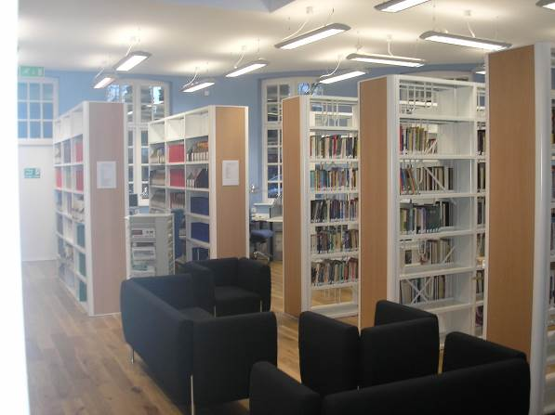 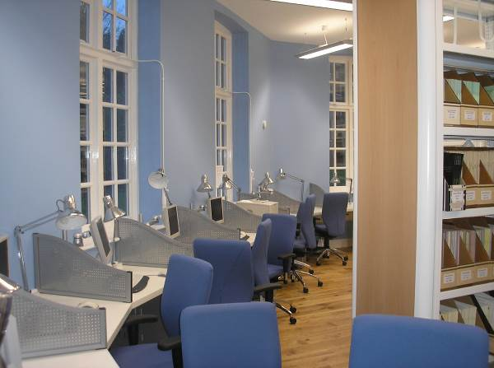

*The Queen’s Foundation library*

### Student support

Given the small nature of the college there is not a dedicated student support centre with staff qualified to provide specialist support. However, we have one contact who is qualified to provide support for those with Specific Learning Difficulties, and who has done so successfully for many of our students. However, **we welcome any recommendations for the provision of support workers from approved providers along with recommendations for adjustments to be made for any student.**

Although we do not have a dedicated student support centre we do provide much more extensive than average dedicated personal tutoring and pastoral care systems.

For further guidance for assessment centre reviewers, please contact:

David Allen ([d.allen@queens.ac.uk](mailto:d.allen@queens.ac.uk); Tel – 0121 454 1527)