Dying and rising with Christa
A workshop with
Caroline Mackenzie & Nicola Slee

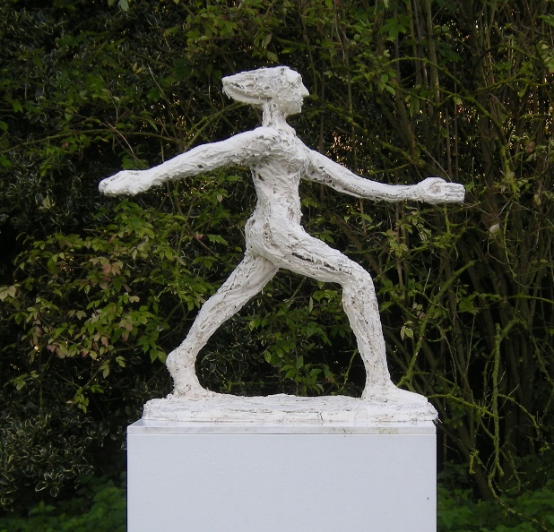

11 May 2019 1030 –1600
Francis Young House at
the Queen’s Foundation
Birmingham B15 2QH

Join us for a day to work with and respond to Caroline Mackenzie’s powerful sculptures of the Christa, charting women’s journey from dejection and depression through anger and crucifixion to resurrection and liberation. Caroline will speak about the artwork, Nicola will offer reflections on the Christa in art and read some of her poems.

Participants will have time to share their own responses to the art work, using creative writing or drawing. There will be opportunity to share in a simple ritual at the end of the day. Prints and drawings by Caroline will be exhibited and for sale, and copies of Seeking the Risen Christa.

The day is open to all. £15 waged and £5 unwaged. Please bring your own lunch. Drinks will be provided. Use the booking form to reserve a place.
Timetable

1030 Arrivals and drinks (please come to the Lecture Suite at Frances Young House (details below)

1100 A conversation with Caroline Mackenzie

1200 The Christa in the visual arts and theology (Nicola Slee)

1300 Lunch (bring your own)

1400 Opportunity for creative writing and/or drawing

1500 Simple liturgy, with chance to read and share our own creative responses

1600 Tea and departures

Friends and visitors welcome to join us at 1500 for liturgy and tea. Donations towards the cost of transporting the sculptures welcome.

Details about parking and venue
The event takes place in Francis Young House, Birmingham, which is up the road from the main Queen’s Campus, next to the BMI Hospital, in Somerset Road, 5 2QH. Further details available from http://www.queens.ac.uk/contact/how-to-find-us

Please note that parking is at the main site at Queen’s (which now has a large carpark for around 50 cars).

Caroline Mackenzie is
a graduate of St Martin’s School of Art, London. After 12 years in India connecting her art with theology, Caroline returned to the UK in 1988, where she has been developing the western tradition of the female figure to express her agency. She is especially interested in how sculptures in public places can empower women and enable men to view them as whole human beings.

Nicola Slee is
Director of Research at the Queen’s Foundation, and Professor of Feminist Practical Theology at the Vrije Universiteit, Amsterdam. She has taught feminist theology for more than 30 years, and has a long standing interest in the Christa. Amongst her many publications, she is author of Seeking the Risen Christa (SPCK, 2011).

